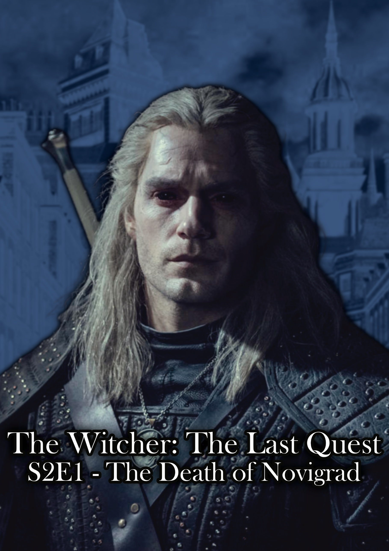

Season 2 – Episode 1: The Death of Novigrad

0:00-0:04:

We start on a black screen. Cracker Island by Gorillaz starts to play on the beat drop and lyric: “Born” at second 4 the screen blares to color instantaneously.

0:04 – 0:08:

A strumpet moves through the docks, the camera on her heels hitting the stones for 2 seconds then switching to her hips swaying for 2. On the lyric “Dawn” we change to:

0:08- 0:12:

Skellige sailors are in a bar fight, a man screams on fire at he runs through the fight, on the lyric “night” we change to:

0:12 – 0:16:

Dijkstra trading a folder with someone in a hood discussing silently in a dark alleyway as the camera slowly pulls back, on the lyric and third syllable of “paradise” we change:

0:16 – 0:20:

Back to the strumpet walking through the streets smiling, closer to her face, and during the section:

“Where the truth was autotuned.”

The screen glitches 3 times to the rhythm of the song, to a woman tied up and burnt to death in the center of the square on a pyre in line with the strumpet, and on “tuned” and the final beat we cut to:

0:20 – 0:32:

During this section:

And its sadness, I consumed (Forever cult)

Into my formats everyday (Forever cult)

In the end, I had to pay (What world is this?)

The woman fully. We slowly move back from the woman burnt on the stake, a member of the cult of the eternal fire is giving a sermon, and people are cheering dressed in cult uniforms as the skeleton’s head, tilts slowly focusing on the camera, face as if she was screaming, staring into the soul of the audience. On the lyric “pay” we cut to…

0:32 – 0:46:

During this section:

In the end, I had to pay (I purged my soul)

In the end, I had to pay (I drank to riot)

Nothing more to say (I drank to riot)

A man vomiting in the bits as the camera moves towards the gate, people in cloaks walk around, someone gets stabbed to death on screen and robbed. A group of men dressed in gang uniforms are in front of a house guarding it.

On the final “riot” the song cults softly, i.e. fades out rapidly as we see Geralt enter the bits.

The sound is entirely environmental we see a man running as he juts past him and a group of gang members chase him. He turns forward, and we get the scene of the bits, we cut back to his face as he sighs and says:

“Fucking Novigrad…”

0:46 – 1:03:

The song comes back into this part:

They taught themselves to be occult

They didn't know its many strategies

They taught themsеlves to be occult

They didn't know its many stratеgies (Fantasies)

***TITLE SCREEN:  
THE WITCHER – Episode 01: The Death of Novigrad***

1:03 – 1:58:  
  
This part is the rest of most of the lyrics of the song, as it plays, we follow Geralt as he walks through the bits and streets of Novigrad to the lyrics seeing different scenes of the chaos:

[Post-Chorus: Thundercat]

What world is this?

What world is this?

[Verse 2: 2-D & Thundercat]

On Cracker Island, it was raised (Hey, hey, hey, hey)

By the collective from the grave (Hey, hey, hey, hey)

It only came out at night (Hey, hey, hey, hey)

It ate up their paradise (Paradise)

Where the truth was auto-tuned (Forever Cult)

And its sadness, I consumed (Forever Cult)

Into my formats everyday (Forever Cult)

In the end, I had to pay (What world is this?)

Out there on my silver lake (I was not there)

In the end, it will be great (Beneath the hills)

I'm like a ship between the tides (I saw myself)

I held on, I survived (There in the void)

And it rapidly fade-cuts like before as Geralt enters a bar.

*Author’s Note:*

*The characters and world of The Witcher belong to Andrzej Sapkowski and CD Projekt Red. This script, the dialogue, story flow, and narrative choices, or anything that is my original work is protected under Australian copyright law (registration pending). It is not intended for commercial use. Any use of this material without permission is prohibited, though reaction videos, breakdowns, and discussions are welcome and permitted in the spirit of collaboration. Additionally, artwork based on this is allowed, however I cannot guarantee, authorize or otherwise state that the shareholders will feel the same.*